$115,000.00
DR PROPERTIES, LLC – DOUBLE EDGE CONSTRUCTION, INC
722 5TH AVENUE WEST
MOBRIDGE – GRAND CROSSING ADDN, BLOCK 54, LOT 12
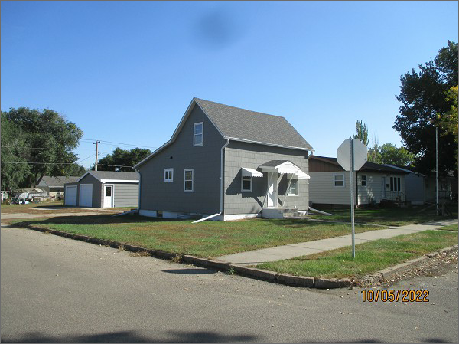
RECORD #5411
LOT SIZE: 50’ X 140’
YEAR BUILT: 1920
TYPE: SINGLE FAMILY
QUALITY: FAIR
CONDITION: AVERAGE
GROUND FLOOR AREA: 624 SQFT
BASEMENT: 624 SQFT
BEDROOMS: 1. BATHS: 1.5
FIXTURES: 5
GARAGE – DETACHED: 672 SQFT
SOLD ON 4/4/2022 FOR $115,000
SOLD ON 10/20/2020 FOR $11,500
ASSESSED IN 2022 AT $27,650
ASSESSED IN 2020 AT $26,490

