$156,000.00
CONLON/GEIST – TROYER
322 6TH STREET WEST
MOBRIDGE – GRAND CROSSING ADDN., BLK 47, LOT 7A
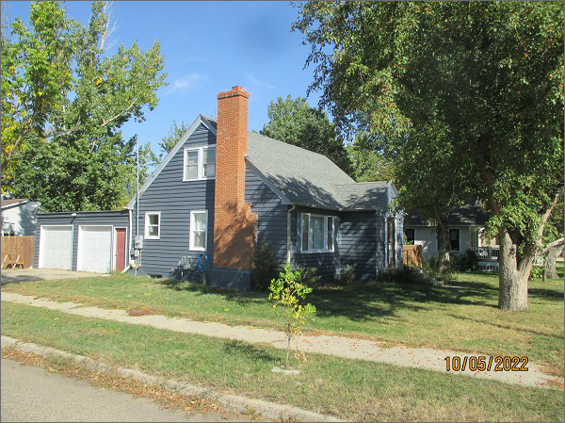
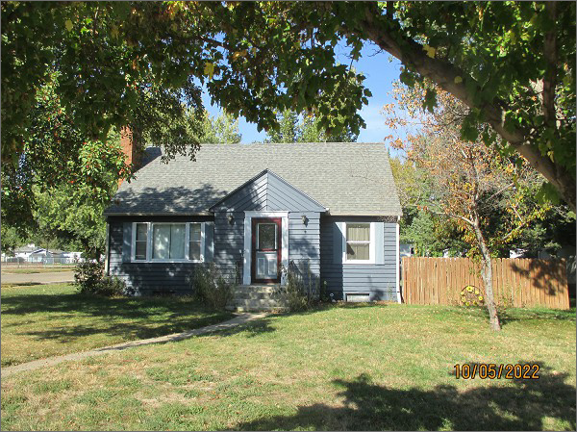
RECORD #5363
LOT SIZE: 70’ X 150’
YEAR BUILT: 1950
TYPE: SINGLE FAMILY
QUALITY: AVERAGE
CONDITION: AVERAGE
GROUND FLOOR AREA: 884 SQFT
BASEMENT: 884 SQFT
BEDROOMS: 2. BATHS: 2.5
FIXTURES: 8
GARAGE – ATTACHED: 432 SQFT
SOLD ON 8/2/2022 FOR $156,000
SOLD ON 10/19/2018 FOR $93,000
ASSESSED IN 2022 AT $78,050
ASSESSED IN 2017 AT $78,870

