$120,000
DADY – ROYAL RENALS LLC
521 4TH AVENUE WEST
MOBRIDGE – GRAND CROSSING ADDN., LOT 1, BLOCK 37
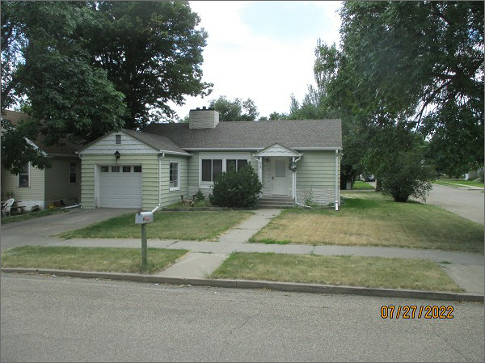
RECORD #5283
LOT SIZE: 50’ X 140’
YEAR BUILT: 1940
TYPE: SINGLE FAMILY
QUALITY: FAIR
CONDITION: AVERAGE
GROUND FLOOR AREA: 1090 SQFT
BASEMENT: 1090 SQFT
BEDROOMS: 4. BATHS: 2.5
FIXTURES: 8
GARAGE – ATTACHED: 182 SQFT
SOLD ON 4/27/22 FOR $120,000
SOLD ON 10/1-20 FOR $76,000
ASSESSED IN 2022 AT $58,960
ASSESSED IN 2017 AT $57,800

