$72,000
FAEHNRICH – UMALI
417 3RD AVENUE WEST
MOBRIDGE – GRAND CROSSING ADDN., LOT 2, BLOCK 29
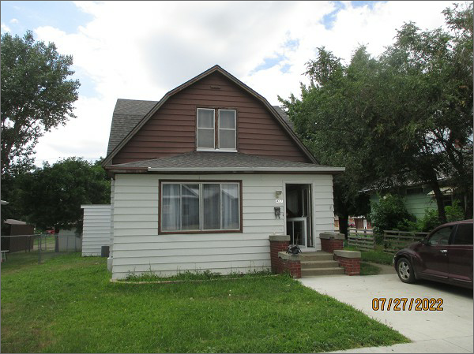
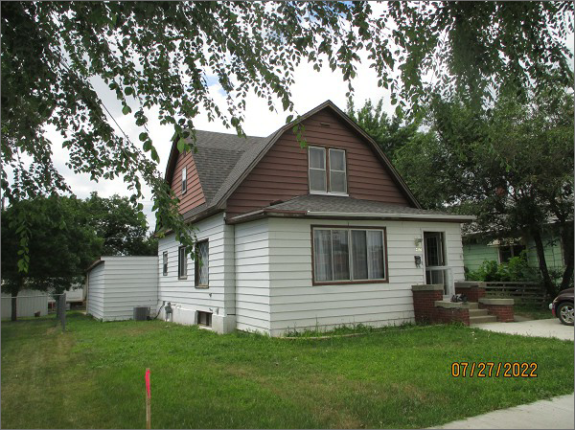
RECORD #5219
LOT SIZE: 50’ X 140’
YEAR BUILT: 1930
TYPE: SINGLE FAMILY
QUALITY: FAIR
CONDITION: AVERAGE
GROUND FLOOR AREA: 1407 SQFT
BASEMENT: 775 SQFT
BEDROOMS: 3. BATHS: 2
FIXTURES: 8
GARAGE – ATTACHED: 448 SQFT
SOLD ON 7/7/22 FOR $72,000
SOLD ON 3/6/20 FOR $35,000
SOLD ON 6/5/19 FOR $12,520
ASSESSED IN 2022 AT $37,560
ASSESSED IN 2019 AT $14,635

