$40,000.00
SPRINGER-CSAKI – CHRIS LANG RENTALS LLC
305 3RD AVENUE WEST
MOBRIDGE – GRAND CROSSING ADDN, BLOCK 28, LOT 5
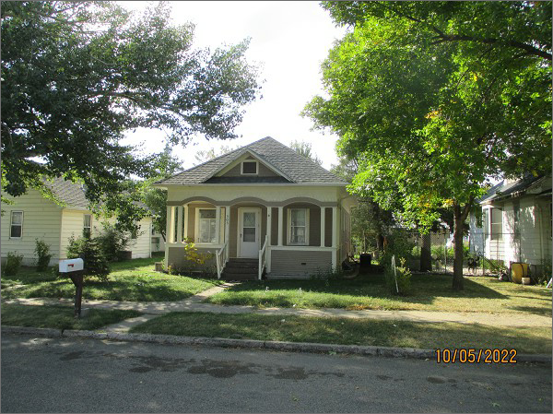
RECORD #5209
LOT SIZE: 50’ X 140’
YEAR BUILT: 1930
TYPE: SINGLE FAMILY
QUALITY: FAIR
CONDITION: AVERAGE
GROUND FLOOR AREA: 876 SQFT
BASEMENT: 858 SQFT
BEDROOMS: 1. BATHS: 1
FIXTURES: 5
GARAGE – DETACHED: 240 SQFT
SOLD ON 5/10/2022 FOR $40,000
SOLD ON 6/9/2015 FOR $52,500
ASSESSED IN 2022 AT $30,180
ASSESSED IN 2015 AT $30,180

