$125,000.00
SAUER – BRAUN
518 CRESCENT STREET
MOBRIDGE – BEL AIRE 1ST ADDN, BLOCK 5, LOT 1
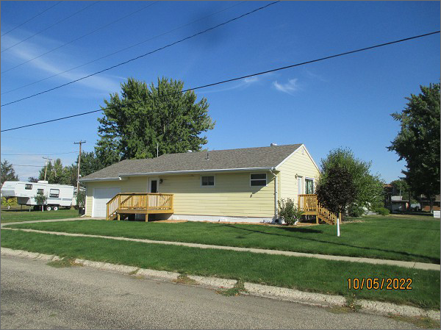
RECORD #4717
LOT SIZE: 65’ X 130’
YEAR BUILT: 1959
TYPE: SINGLE FAMILY
QUALITY: FAIR
CONDITION: AVERAGE
GROUND FLOOR AREA: 864 SQFT
BASEMENT: 864 SQFT
BEDROOMS: 2. BATHS: 1
FIXTURES: 5
GARAGE – ATTACHED: 336 SQFT
SOLD ON 7/14/2022 FOR $125,000
SOLD ON 4/18/2017 FOR $98,000
ASSESSED IN 2022 AT $96,490
ASSESSED IN 2017 AT $75,870

