$110,000
M & C RENTAL PROPERTIES – LOWE & LOOP
516 12TH STREET WEST
MOBRIDGE – BEL AIRE 1ST ADDN., LOT 31, BLOCK 2
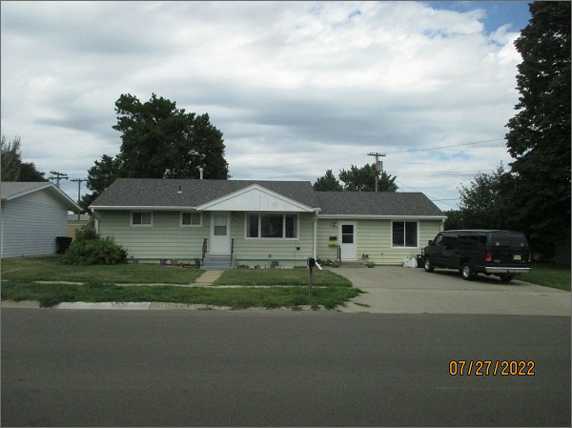
RECORD #4716
LOT SIZE: 115’ X 86.25’
YEAR BUILT: 1958
TYPE: SINGLE FAMILY
QUALITY: FAIR
CONDITION: AVERAGE
GROUND FLOOR AREA: 1450 SQFT
BASEMENT: 864 SQFT
BEDROOMS: 3. BATHS: 2
FIXTURES: 8
SOLD ON 6/3/22 FOR $110,000
SOLD ON 5/9/17 FOR $65,000
SOLD ON 3/2/17 FOR $40,000
ASSESSED IN 2022 AT $77,910
ASSESSED IN 2017 AT $67,770

