$97,000
WALTHER – TYNES & ROLLINS
1212 PARK LANE
MOBRIDGE – BEL AIRE 1ST ADDN., LOT 28, BLOCK 1
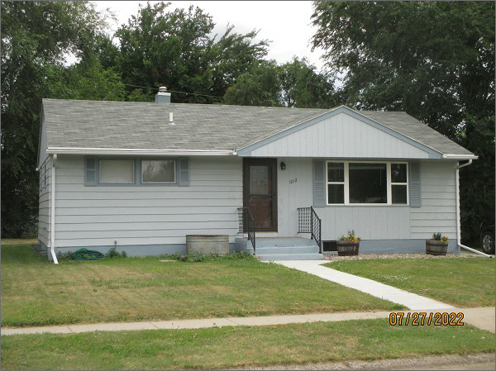
RECORD #4707
LOT SIZE: 60’ X 123.6’
YEAR BUILT: 1960
TYPE: SINGLE FAMILY
QUALITY: FAIR
CONDITION: AVERAGE
GROUND FLOOR AREA: 960 SQFT
BASEMENT: 960 SQFT
BEDROOMS: 4. BATHS: 1.75
FIXTURES: 7
SOLD ON 12/28/21 FOR $97,000
SOLD ON 4/25/19 FOR $53,600
ASSESSED IN 2022 AT $47,380
ASSESSED IN 2017 AT $45,350

