$75,000.00
JUNGWIRTH – ROYAL RENTALS LLC
410 12TH STREET WEST
MOBRIDGE – BEL AIRE 1ST ADDN, BLOCK 1, LOT 2
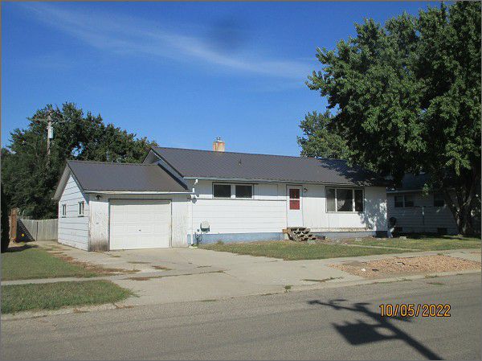
RECORD #4697
LOT SIZE: 67’ X 100’
YEAR BUILT: 1965
TYPE: SINGLE FAMILY
QUALITY: LOW/FAIR
CONDITION: AVERAGE
GROUND FLOOR AREA: 1200 SQFT
BASEMENT: 1200 SQFT
BEDROOMS: 4. BATHS: 1.75
FIXTURES: 8
GARAGE – ATTACHED: 336 SQFT
SOLD ON 5/25/2022 FOR $75,000
ASSESSED IN 2022 AT $83,510
ASSESSED IN 2017 AT $80,790

