$25,000.00
SHARON M BECK REVOCABLE TRUST – ERDMANN PROPERTIES, LLC
SKINNER STREET
AKASKA – ORIGINAL, BLOCK 22, LOTS 4 & 5
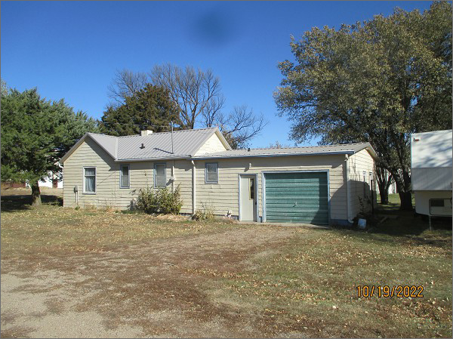
RECORD #3913
LOT SIZE: 115.2’ X 132’
YEAR BUILT: 1920
TYPE: SINGLE FAMILY
QUALITY: LOW
CONDITION: BADLY WORN
GROUND FLOOR AREA: 1056 SQFT
BEDROOMS: 1. BATHS: 1
FIXTURES: 6
GARAGE – ATTACHED: 384 SQFT
SOLD ON 3/14/2022 FOR $25,000
ASSESSED IN 2022 AT $51,760
ASSESSED IN 2017 AT $24,930

