$159,900.00
CAVANAUGH – GRAVATT
MAIN STREET
AKASKA – ORIGINAL, BLOCK 14, LOTS 3, 4, 5 & 6
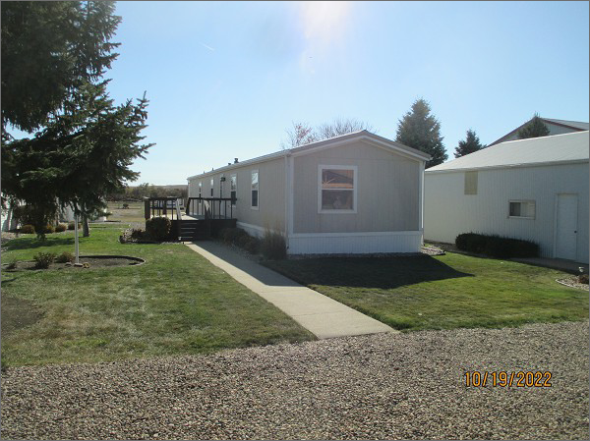
RECORD #3882
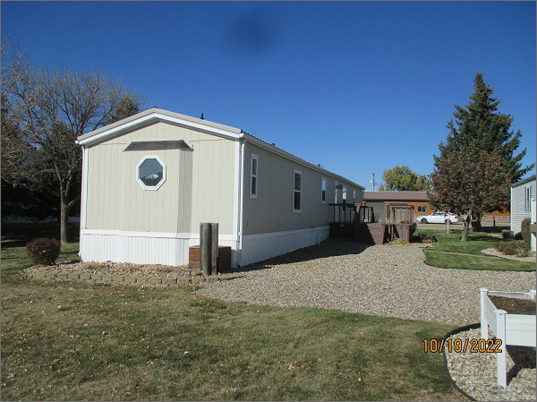

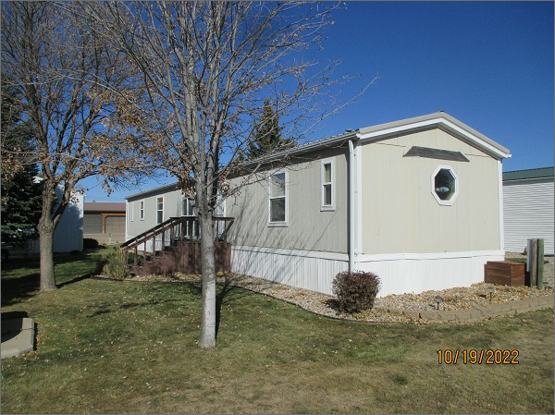
LOT SIZE: 96’ X 125’
YEAR BUILT: 1996
TYPE: MOBILE HOME
QUALITY: AVERAGE
CONDITION: AVERAGE
SIZE OF MOBILE HOME: 16’ X 80’
BEDROOMS: 3. BATHS: 1.75
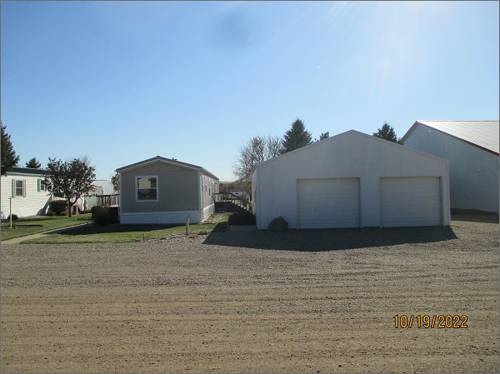
FIXTURES: 5
GARAGE – DETACHED: 960 SQFT
SOLD ON 6/30/2022 FOR $159,900
ASSESSED IN 2022 AT $71,020
ASSESSED IN 2019 AT $61,340
ASSESSED IN 2017 AT $8,920

