$78,000.00
MILLER LIVING TRUST U/D/T – LITZEN & DWYER
209 COFFEY STREET
AKASKA – ORIGINAL, BLOCK 10, LOT 1
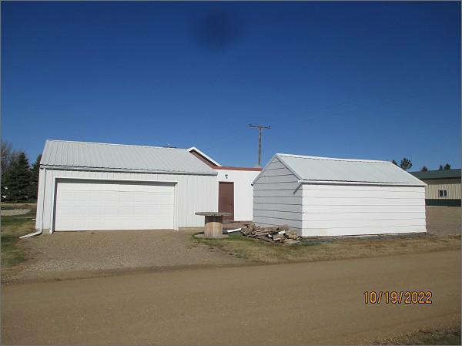
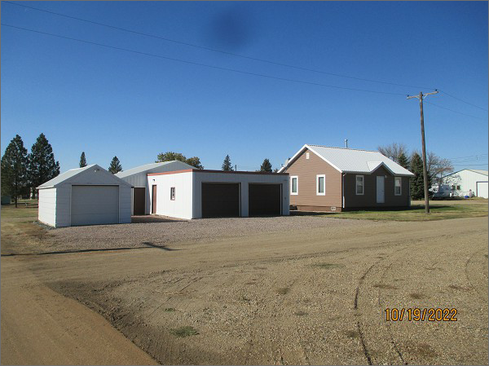
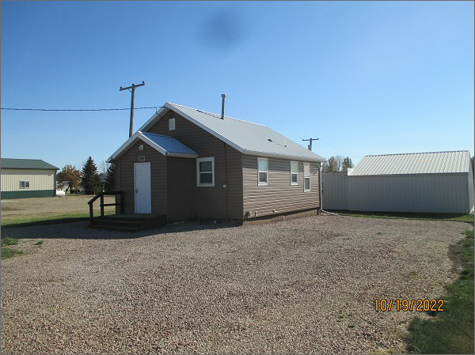
RECORD #3849
LOT SIZE: 57.6’ X 132’
YEAR BUILT: 1940
TYPE: SINGLE FAMILY
QUALITY: FAIR
CONDITION: AVERAGE
GROUND FLOOR AREA: 672 SQFT
BASEMENT: 672 SQFT
BEDROOMS: 2. BATHS: 1.5
FIXTURES: 6
GARAGE – 3 DETACHED: TOTAL 1584 SQFT
SOLD ON 9/3/2021 FOR $78,000
ASSESSED IN 2022 AT $60,340
ASSESSED IN 2021 AT $59,040
ASSESSED IN 2017 AT $27,345

