$106,000
BERENS – HATHAWAY
29949 132ND ST
BERENS OUTLOT IN NE4NW4 OF 18-123-77
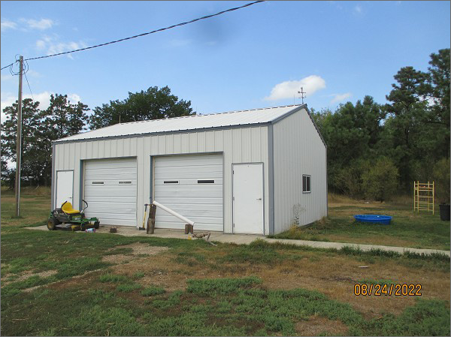
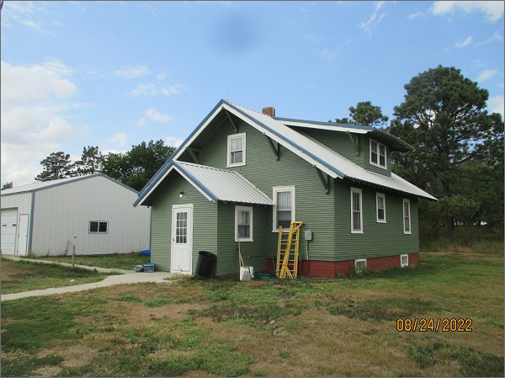
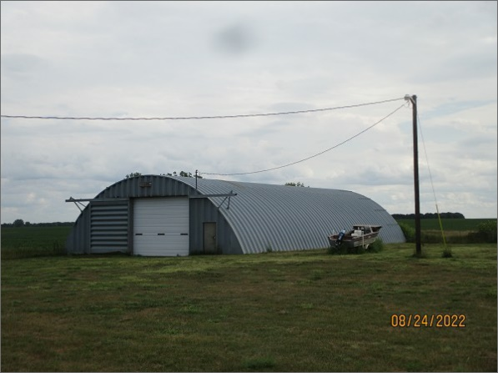
RECORD #8991
PLATED OUT OF RECORD #2162
LOT SIZE: 5.46 ACRES
YEAR BUILT: 1930
TYPE: SINGLE FAMILY
QUALITY: FAIR
CONDITION: BADLY WORN
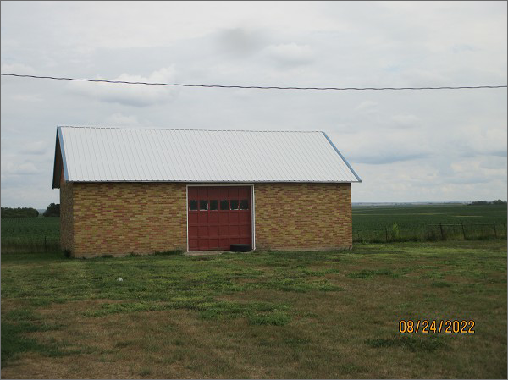
GROUND FLOOR AREA: 816 SQFT
BASEMENT: 816 SQFT
BEDROOMS: 3. BATHS: 2
GARAGE – DETACHED: 864 SQFT
QUONSET: 5,000 SQFT
BRICK SHED BUILDING: 1,000 SQFT
SOLD ON 7/12/22 FOR $106,000
ASSESSED IN 2022 AT $93,225

