$55,000
LANG – BARTON
12752 THUNDER ROAD
LOT 1 HOCHHALTER-LANG ADDN SW4NW4SE4 21-124-79
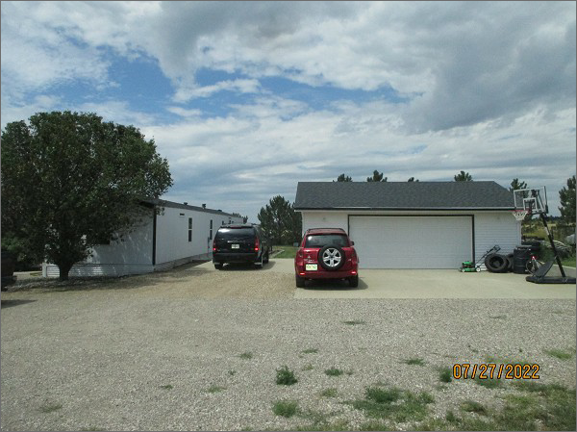
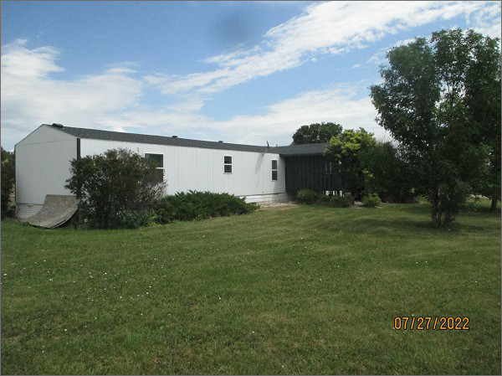
RECORD #7839
LOT SIZE: 1.32 ACRES
YEAR BUILT: 1992
TYPE: MANUFACTUED HOME
QUALITY: AVERAGE
CONDITION: AVERAGE
GROUND FLOOR AREA: 1072 SQFT
BEDROOMS: 3. BATHS: 1.5
GARAGE – DETACHED: 672 SQFT
SOLD ON 2/4/22 FOR $55,000
ASSESSED IN 2022 AT $37,000
ASSESSED IN 2017 AT $38,720
ASSESSED IN 2014 AT $45,410

