$199,000
SCHLOMER – OGREN
106 2ND AVENUE WEST
GLENHAM – MILW LAND CO’S 2ND ADDN, LOTS 5 & 6, BLOCK 12
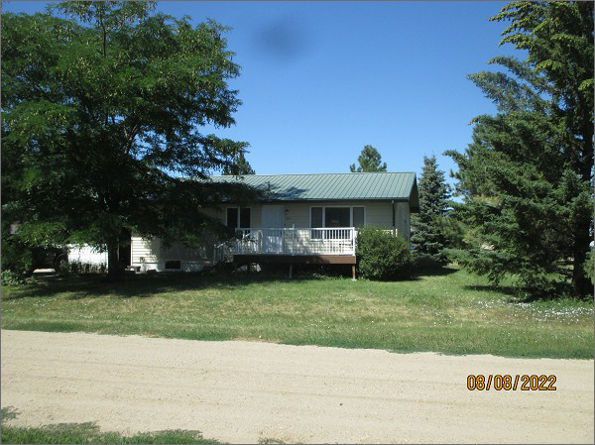
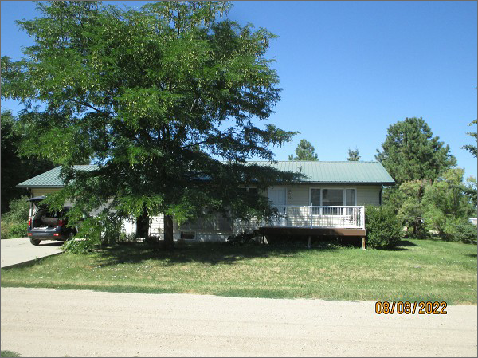
RECORD #6669
LOT SIZE: 100’ X 140’
YEAR BUILT: 1988
TYPE: SINGLE FAMILY
QUALITY: AVERAGE
CONDITION: AVERAGE
GROUND FLOOR AREA: 1120 SQFT
BASEMENT: 1120 SQFT
BATHS: 2
FIXTURES: 8
GARAGE – ATTACHED: 672 SQFT
SOLD ON 7/30/22 FOR $199,000
ASSESSED IN 2022 AT $94,185
ASSESSED IN 2016 AT $91,770

