**$110,000**

**MOSER-ULMER**

**915 4TH AVE WEST, MOBRIDGE**

**NWTS 1ST ADDN LOT 2 BLOCK 8**

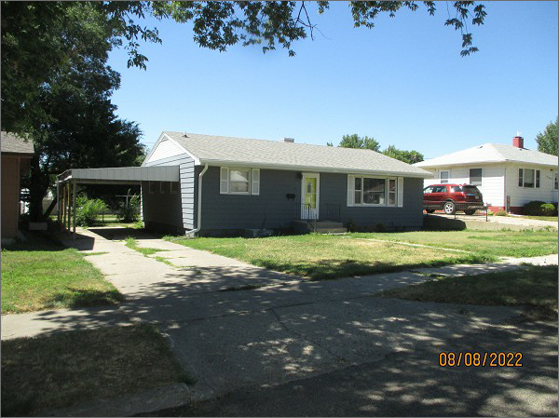**RECORD #5942**

**LOT SIZE 60’ X 140’**

**YEAR BUILT 1965**

**TYPE: SINGLE FAMILY**

**QUALITY: FAIR**

**CONDITION: AVERAGE**

**GROUND FLOOR AREA: 1120 SQFT**

**BASEMENT: 1120 SQFT**

**BEDROOMS: 2. BATHS: 1.25**

**FIXTURES: 8**

**CARPORT GARAGE: 286 SQFT**

**SOLD ON 3/25/22 FOR $110,000**

**ASSESSED IN 2022 AT $86,840**

**ASSESSED IN 2017 AT $84,070**