$50,000.00
WHILE-GOSCH
1020 5TH AVENUE WEST
MOBRIDGE NWTS 1ST ADDN N 17 ½’ OF LOT 13 & ALL OF 14 BLOCK 3
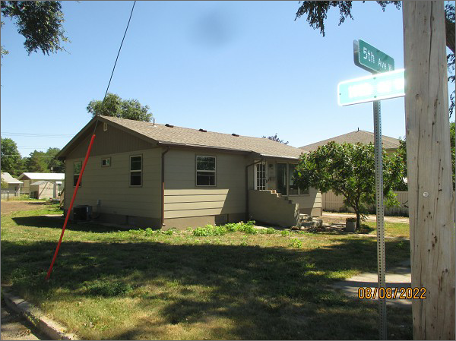
RECORD #5925
LOT SIZE 55’ X 140’
YEAR BUILT: 1965
TYPE: SINGLE FAMLIY
QUALITY: FAIR
CONDITION: AVERAGE
GROUND FLOOR AREA: 1368 SQFT
BASEMENT: 1008 SQFT
BEDROOMS: 3
BATHS: 2
FIXTURES: 11
SOLD ON 2/18/22 FOR $50,000
ASSESSED IN 2022 AT $58,770
ASSESSED IN 2020 AT $49,936

