$90,000
TB PROPERTIES, LLC - RYGH
912 2ND AVENUE EAST
MOBRIDGE – MAIN PARK, NORTH 6.75’ OF LOT 13, ALL OF LOT 14 & SOUTH ½ OF LOT 15, BLOCK 6
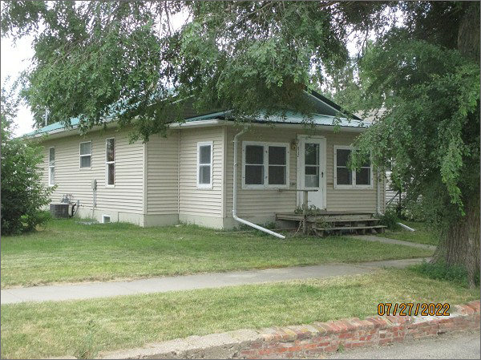
RECORD #5597
LOT SIZE: 63’ X 142’
YEAR BUILT: 1911
TYPE: SINGLE FAMILY
QUALITY: FAIR
CONDITION: AVERAGE
GROUND FLOOR AREA: 924 SQFT
BASEMENT: 912 SQFT
BEDROOMS: 2. BATHS: 1.25
FIXTURES: 7
GARAGE – DETACHED: 308 SQFT
SOLD ON 6/1/22 FOR $90,000
ASSESSED IN 2022 AT $30,090
ASSESSED IN 2017 AT $27,180

