$195,000
ANDERSON – JOB
915 3RD AVENUE EAST
MOBRIDGE – MAIN PARK, SOUTH 17 ½’ OF LOT 4, ALL OF LOT 5 & NORTH 10’ OF LOT 6, BLOCK 6
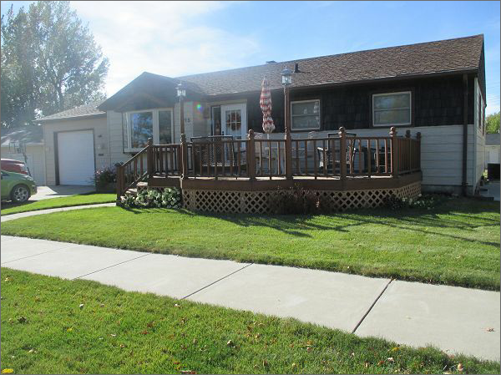
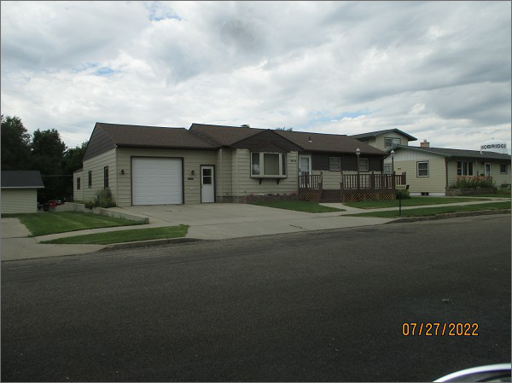
RECORD #5592
LOT SIZE: 65’ X 142’
YEAR BUILT: 1965
TYPE: SINGLE FAMILY
QUALITY: FAIR
CONDITION: AVERAGE
GROUND FLOOR AREA: 1051 SQFT
BASEMENT: 1025 SQFT
BEDROOMS: 3. BATHS: 2
FIXTURES: 8
GARAGE – ATTACHED: 594 SQFT
SOLD ON 7/26/22 FOR $195,000
ASSESSED IN 2022 AT $124,700
ASSESSED IN 2016 AT $115,000

