$250,000.00
HUFFMAN-FIEDLER
715 3RD AVENUE EAST. MOBRIDGE
MOBRIDGE, GRAND CROSSING ADDN, S 26’ OF LOT 16B & ALL OF LOT 16C, BLOCK 61
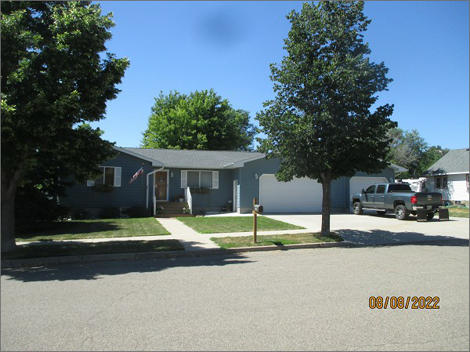
RECORD #5508
LOT SIZE: 69’ X 140’
YEAR BUILT: 1994
TYPE: SINGLE FAMILY
QUALITY: FAIR
GROUND FLOOR AREA: TOTAL AREA (BASEMENT INCLUDED): 1057 SQFT
BEDROOMS: 3
PLUMBING: BATHS- 1 FIXTURES- 5
SOLD ON 1/31/22 FOR $250,000
SOLD ON 6/24/13 FOR $93,000
ASSESSED IN 2022 AT $124,220
ASSESSED IN 2013 AT $40,649
ASSESSED IN 2014 AT $106,310
ADDED 33’X38’ ATTACHED GARAGE IN 2014

