$56,058
TB PROPERTIES LLC - GRAVES
32 4TH AVE EAST
MOBRIDGE- EKLO’S 2ND ADDN W ½ OF N ½ OF LOT 1
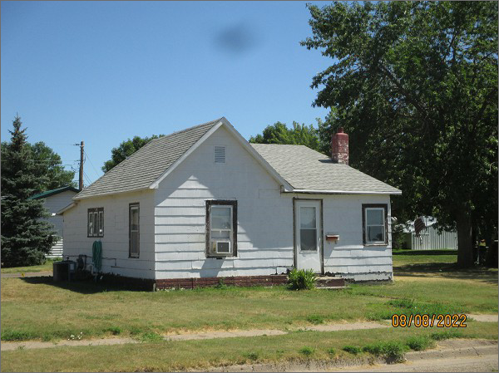
RECORD #4952
LOT SIZE: 69.9’ X 150’
YEAR BUILT: 1930
TYPE: SINGLE FAMILY
QUALITY: LOW/FAIR
CONDITION: BADLY WORN
GROUND FLOOR AREA: 768 SQFT
BEDROOMS: 1
BATHS: 1
FIXTURES: 5
GARAGE – DETACHED: 724 SQFT
SOLD ON 3/4/22 FOR $56,068
ASSESSED IN 2022 AT $24,820
ASSESSED IN 2017 AT $24,820

