$60,000
PRUSHA - TROYER
1222 PARK LANE
MOBRIDGE, BEL AIRE 1ST ADDN, LOT 26, BLOCK 1
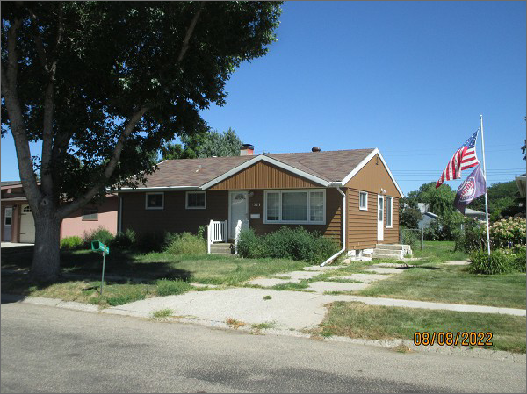
RECORD #4705
LOT SIZE: 60’ X 125’
YEAR BUILT: 1960
TYPE: SINGLE FAMILY
QUALITY: FAIR
CONDITION: AVERAGE
GROUND FLOOR AREA: 912 SQFT
BASEMENT: 912 SQFT
BEDROOMS: 2. BATHS: 1.5
FIXTURES: 7
SOLD ON 3/17/22 FOR $60,000
ASSESSED IN 2022 AT $84,140
ASSESSED IN 2017 AT $81,460

