$280,000
MARSHALL – WEINHART
110 WEST TOWER ST
SELBY – PLAINVIEW 1ST, LOTS 1 & 2, BLOCK 9
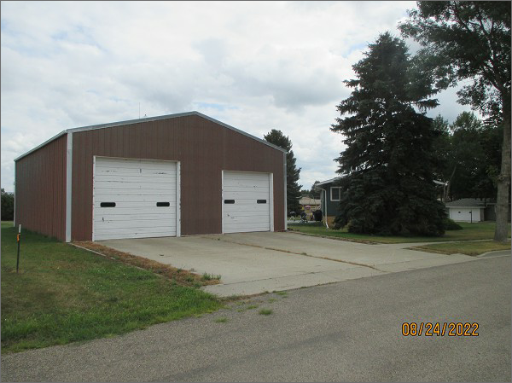
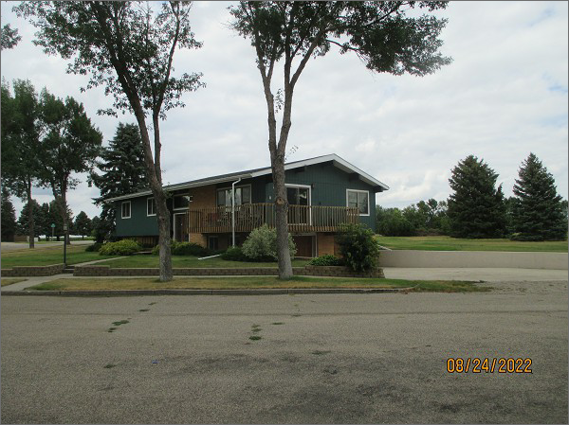
RECORD #4633
LOT SIZE: 159’ X 140’
YEAR BUILT: 1968
TYPE: SINGLE FAMILY
QUALITY: AVERAGE
CONDITION: AVERAGE
GROUND FLOOR AREA: 1590 SQFT
BASEMENT: 924 SQFT
BEDROOMS: 3. BATHS: 2.5
FIXTURES: 7
GARAGE – BUILT IN: 616 SQFT
METAL SHOP: 1440 SQFT
SOLD ON 6/10/22 FOR $280,000
SOLD ON 6/14/19 FOR $167,500
ASSESSED IN 2022 AT $136,050
ASSESSED IN 2017 AT $110,010

