$185,000
SAWINSKY – HEIN
6305 4TH AVENUE
SELBY – PLAINVIEW 1ST, LOT 2 & S. 60’ OF LOT 3, BLOCK 5
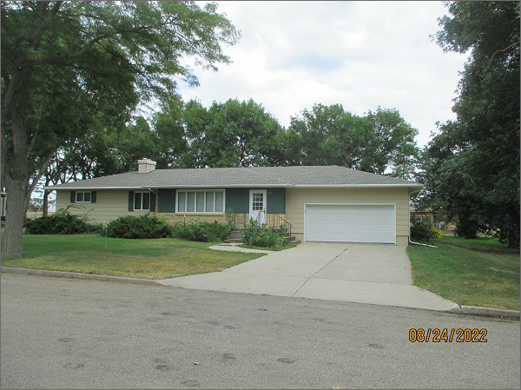
RECORD #4624
LOT SIZE: 120’ X 140’
YEAR BUILT: 1967
TYPE: SINGLE FAMILY
QUALITY: AVERAGE
CONDITION: BADLY WORN
GROUND FLOOR AREA: 1700 SQFT
BASEMENT: 1700 SQFT
BEDROOMS: 3. BATHS: 2.5
FIXTURES: 10
GARAGE – ATTACHED: 660 SQFT
SOLD ON 5/5/22 FOR $185,000
ASSESSED IN 2022 AT $161,330
ASSESSED IN 2017 AT $157,170

