$49,200
BLOCK – RAU
110 WEST DAKOTA ST
SELBY – PLAINVIEW 1ST, LOT 1, BLOCK 5
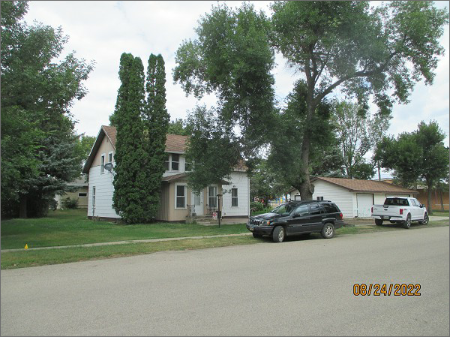
RECORD #4623
LOT SIZE: 110’ X 140’
YEAR BUILT: 1925
TYPE: SINGLE FAMILY
QUALITY: AVERAGE
CONDITION: AVERAGE
GROUND FLOOR AREA: 999 SQFT
BASEMENT: 999 SQFT
BEDROOMS: 4. BATHS: 2
FIXTURES: 8
GARAGE – DETACHED: 624 SQFT
SOLD ON 2/9/22 FOR $49,200 (FORECLOSURE)
SOLD ON 10/8/15 FOR $69,900
ASSESSED IN 2022 AT $73,370
ASSESSED IN 2014 AT $75,555

