**$32,000**

**SCANNIELLO – SCHANZENBACH**

**3911 OVERHOLSER AVENUE**

**SELBY – OVERHOLSER ADDN, LOT 1 OF TRACT 2 OUTLOT A**

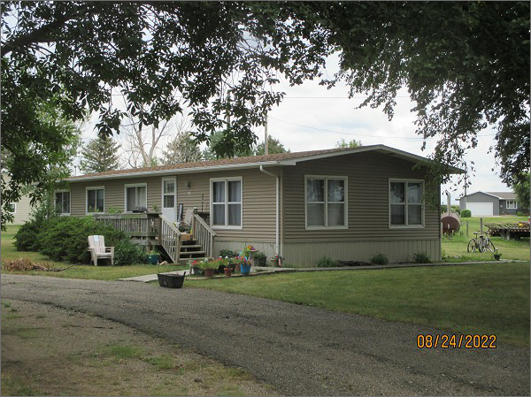**RECORD #4600**

**LOT SIZE: 115’ X 168’ & 20’ X 168’**

**YEAR BUILT: 1974**

**TYPE: MANUFACTURED HOUSING**

**QUALITY: AVERAGE**

**CONDITION: AVERAGE**

**GROUND FLOOR AREA: 1311 SQFT**

**BEDROOMS: 3. BATHS: 1**

**FIXTURES: 8**

**SOLD ON 10/29/21 FOR $32,000**

**SOLD ON 6/8/18 FOR $22,000**

**ASSESSED IN 2022 AT $26,360**

**ASSESSED IN 2021 AT $26,360**

**ASSESSED IN 2017 AT $21,520**