$150,000
WOLFF – FIEDLER
3905 MARIN DRIVE
SELBY – OVERHOLSER ADDN, S. 50’ OF LOT 7 & ALL OF LOT 8 IN TRACT 1 OF OUTLOT A
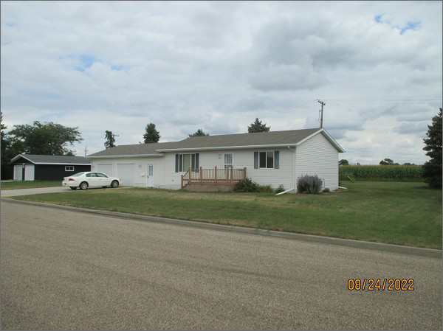
RECORD #4595
LOT SIZE: 150’ X 103.7’
YEAR BUILT: 2006
TYPE: SINGLE FAMILY
QUALITY: AVERAGE
CONDITION: AVERAGE
GROUND FLOOR AREA: 1032 SQFT
BASEMENT: 1032 SQFT
BEDROOMS: 2. BATHS: 1
FIXTURES: 7
GARAGE – ATTACHED: 792 SQFT
SOLD ON 4/18/22 FOR $150,000
ASSESSED IN 2022 AT $99,365
ASSESSED IN 2016 AT $143,240

