$69,000
HUBER - RUEB
510 EAST BANGOR ST
SELBY – OVERHOLSER ADDN, LOTS 5 & 6, BLOCK 5
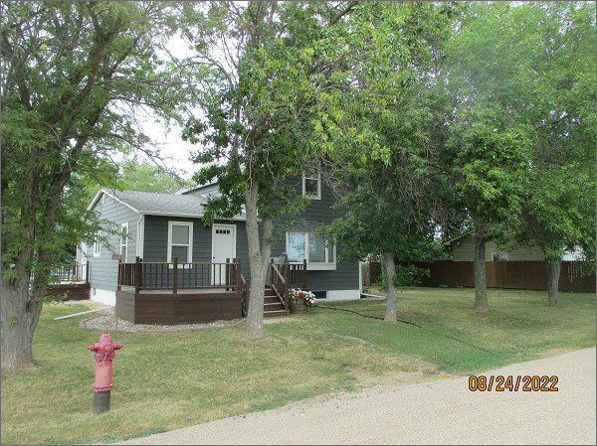
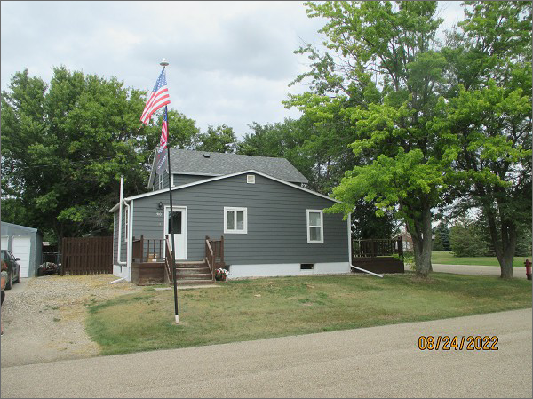
RECORD #4570
LOT SIZE: 100’ X 140’
YEAR BUILT: 1910
TYPE: SINGLE FAMILY
QUALITY: FAIR
CONDITION: BADLY WORN
GROUND FLOOR AREA: 846 SQFT
BASEMENT: 846 SQFT
BEDROOMS: 3. BATHS: 2
FIXTURES: 6
GARAGE – DETACHED: 720 SQFT
SOLD ON 11/2/21 FOR $69,000
SOLD ON 12/15/16 FOR $60,000
ASSESSED IN 2021 & 2022 AT $55,830
ASSESSED IN 2017 AT $52,360

