$17,000
THORSTENSON - GEIER
1610 2ND AVENUE
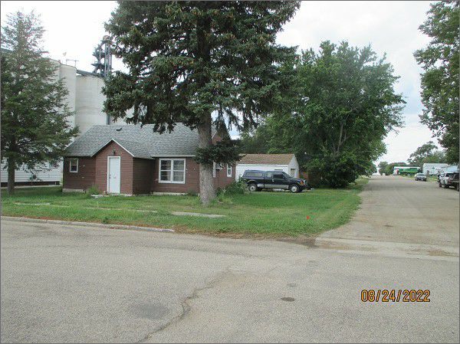
SELBY – ORIGINAL, LOT 1, BLOCK 19
RECORD #4530
LOT SIZE: 50’ X 140’
YEAR BUILT: 1920
TYPE: SINGLE FAMILY
QUALITY: FAIR
CONDITION: BADLY WORN
GROUND FLOOR AREA: 900 SQFT
BEDROOMS: 2. BATHS: 1
FIXTURES: 5
GARAGE – DETACHED: 572 SQFT
SOLD ON 6/30/22 FOR $17,000
SOLD ON 8/22/14 FOR $17,000
ASSESSED IN 2022 AT $16,570
ASSESSED IN 2017 AT $14,840

