$40,000
HEIN - GEDITZ
109 W WALWORTH ST
SELBY ORIGINAL LOT 18 BLOCK 14
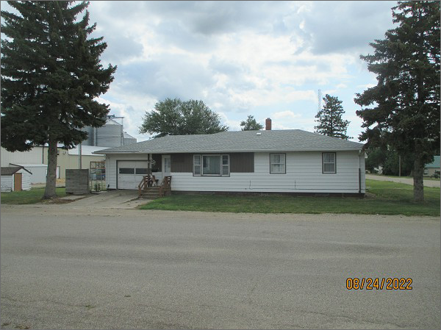
RECORD #4505
LOT SIZE: 50’ X 140’
YEAR BUILT: 1958
TYPE: SINGLE FAMILY
QUALITY: AVERAGE
CONDITION: AVERAGE
GROUND FLOOR AREA: 1132 SQFT
BASEMENT: 1132 SQFT
BEDROOMS: 3. BATHS: 1.75
FIXTURES: 8
GARAGE: DETACHED – 96 SQFT. ATTACHED – 345 SQFT.
SOLD ON 5/24/22 FOR $40,000
ASSESSED IN 2022 AT $49,540
ASSESSED IN 2017 AT $47,810

