$61,500
SOLIS AVILA - WOODLEY
3503 3RD AVENUE
SELBY – ORIGINAL, N. 35’ LOT 8 & ALL LOT 9, BLOCK 9
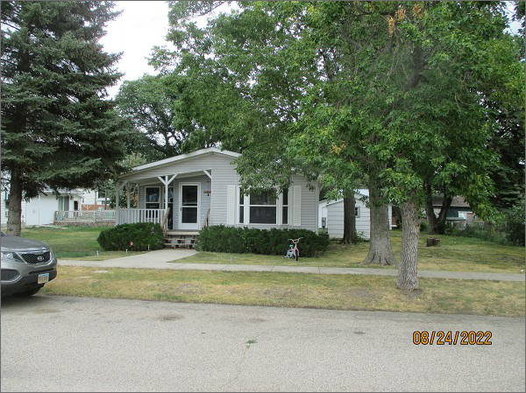
RECORD #4462
LOT SIZE: 85’ X 140’
YEAR BUILT: 1996
TYPE: MANUFACTURED HOUSING
QUALITY: GOOD
CONDITION: AVERAGE
GROUND FLOOR AREA: 1344 SQFT
BEDROOMS: 3. BATHS: 2
FIXTURES: 8
GARAGE – DETACHED: 624 SQFT
SOLD ON 11/9/21 FOR $61,500
SOLD ON 1/10/19 FOR $60,500
ASSESSED IN 2022 AT $60,010
ASSESSED IN 2017 AT $57,070

