$60,000
GOLDADE – CADMAN
4106 6TH AVENUE
SELBY – MILW. OUTLOTS, LOT A OUTLOT D, LOTS 3 & 4
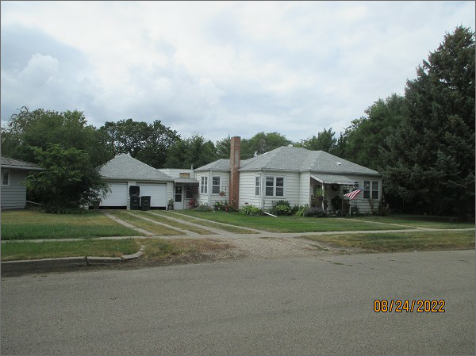
RECORD #4384
LOT SIZE: 100’ X 140’
YEAR BUILT: 1948
TYPE: SINGLE FAMILY
QUALITY: FAIR
CONDITION: AVERAGE
GROUND FLOOR AREA: 1004 SQFT
BASEMENT: 704 SQFT
BEDROOMS: 3 BATHS: 1
FIXTURES: 6
GARAGE – DETACHED: 506 SQFT
SOLD ON 3/3/22 FOR $60,000
ASSESSED IN 2022 AT $24,600
ASSESSED IN 2018 AT $21,130

