$142,000
SALVERSON – PFITZER
3107 6TH AVENUE
SELBY – MILW LAND CO’S 2ND ADDN, LOTS 10 & 11, BLOCK 28
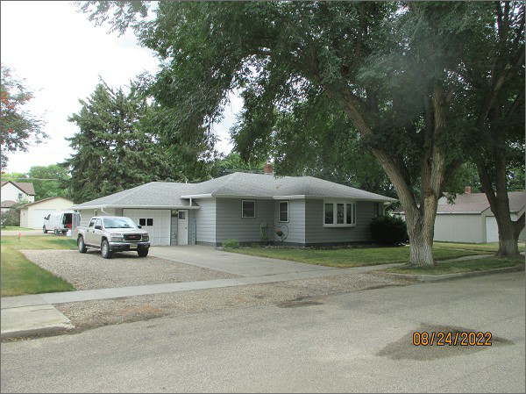
RECORD #4370
LOT SIZE: 100’ X 140’
YEAR BUILT: 1955
TYPE: SINGLE FAMILY
QUALITY: AVERAGE
CONDITION: AVERAGE
GROUND FLOOR AREA: 1342 SQFT
BASEMENT: 1342 SQFT
BEDROOMS: 3. BATHS: 1.75
FIXTURES: 8
GARAGE – ATTACHED: 368 SQFT
SOLD ON 3/28/22 FOR $142,000
SOLD ON 10/22/20 FOR $134,900
ASSESSED IN 2022 AT $109,800
ASSESSED IN 2017 AT $106,330

