$65,000
MILLER - SMITH
5311 4TH AVE
SELBY MILW LAND CO’S 1ST ADDN N 2’ LOT 11 & ALL OF 12 BLOCK 24
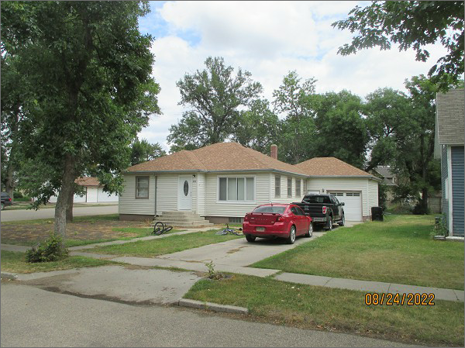
RECORD #4333
LOT SIZE: 52’ X 140’
YEAR BUILT: 1952
TYPE: SINGLE FAMILY
QUALITY: FAIR
CONDITION: AVEAGE
GROUND FLOOR AREA: 1254 SQFT
BASEMENT: 1088 SQFT
BEDROOMS: 2. BATHS: 2
FIXTURES: 7
GARAGE- ATTACHED: 280 SQFT
SOLD ON 6/13/22 FOR $65,000
ASSESSED IN 2022 AT $74,200
ASSESSED IN 2017 AT $87,810

