$41,500
RUTZ - KURTZ
5403 MAIN ST
SELBY – MILW LAND CO’S 1ST ADDN, LOT 8, BLOCK 23
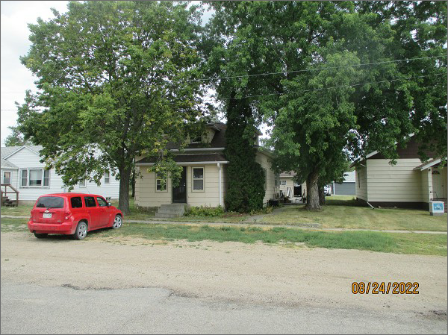
RECORD #4323
LOT SIZE: 50’ X 140’
YEAR BUILT: 1910
TYPE: SINGLE FAMILY
QUALITY: FAIR
CONDITION: BADLY WORN
GROUND FLOOR AREA: 876 SQFT
BASEMENT: FURNACE ROOM ONLY
BEDROOMS: 3. BATHS: 1
FIXTURES: 5
GARAGE – DETACHED: 504 SQFT
SOLD ON 7/8/22 FOR $41,500
SOLD ON 12/27/21 FOR $40,000
ASSESSED IN 2022 FOR $23,620
ASSESSED IN 2017 FOR $21,890

