$50,000
SAUERSSIG – RUEB
2410 MITCHELL ST
JAVA – PAYNE’S PLAT 1ST ADDN, LOTS 5 & 6, BLOCK 4
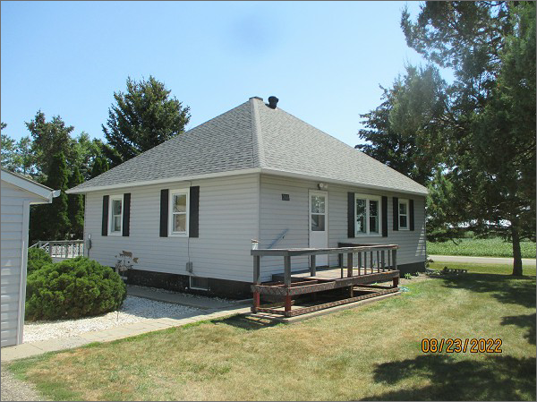
RECORD #4154
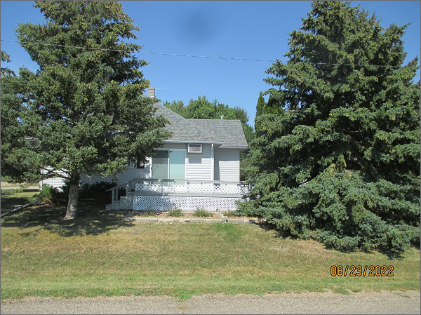
LOT SIZE: 100’ X 140’
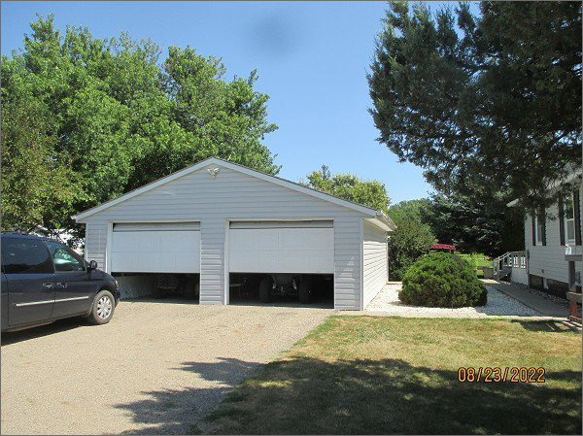
YEAR BUILT: 1954
TYPE: SINGLE FAMILY
QUALITY: FAIR
CONDITION: AVERAGE
GROUND FLOOR AREA: 924 SQFT
BASEMENT: 840 SQFT
BATHS: 1
FIXTURES: 8
GARAGE – DETACHED: 768 SQFT
SOLD ON 2/24/22 FOR $50,000
ASSESSED IN 2022 AT $21,545
ASSESSED IN 2017 AT $18,950

