$35,000.00
LEMBURG – KREIN
2911 OVERHOLSER AVE. SELBY
SELBY OVERHOLSERS ADDN N 100’ OF W 150’ IN LOT 2
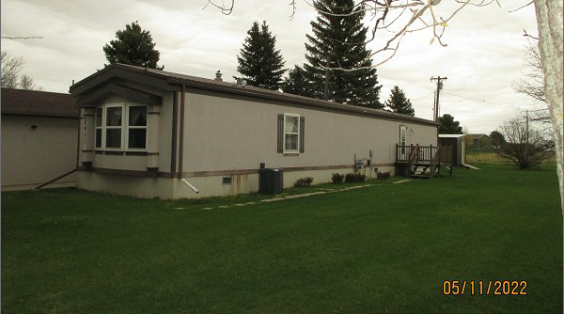
TRACT 2 OUTLOT A
RECORD #7491

LOT SIZE 100’ X 150’ TOTAL LIVING AREA 1216 SQ FT
MH 1987 16’ X 76’ BONNAVILLA 3 BEDROOMS 2 FULL BATHS
AVERAGE QUALITY & CONDITION WOOD DECK 10’ X 12’
2015; VERTICAL HARDBOARD
CENTRAL AIR – NATURAL GAS
DETACHED GARAGE 24’ X 20’
UTILITY SHED 8’ X 10’
SOLD ON 9/23/21 FOR $35,000
ASSESSED IN 2021 AT $38,540
SOLD ON 8/21/20 FOR $35,010
ASSESSED IN 2019 AT $35,000 RECORD #7491

