$110,000.00
OAKS – KVARNESS
324 SOUTH RAILWAY ST. SELBY
SELBY MISC. LOT A OF THE SE4NW4 & LOT 1 GOEBEL ADDN IN
N2SE4NW4 4-123-76
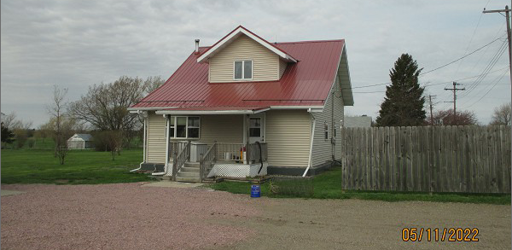
RECORD #6762 & 6763

5.02 TOTAL ACRES MAIN LIVING 936 SQ FT
SINGLE FAMILY – 1 ½ STORY TOTAL LIVING 1357 SQ FT
AVERAGE QUALITY & CONDITION 3 BEDROOMS 2 BATHS
BUILT IN 1910 + - BSMT 754 SQ FT
2015; CENTRAL AIR, NEWER WINDOWS BSMT 377 SQ FT FIN REC
2011; REMODEL BSMT, 2010 NEW FURNACE SWP 64 SQ FT
2010; REMODEL INTERIOR WOOD DECK 140 SQ FT
2018; NEW SIDING AND ROOF GARAGE 24’ X 24’
SOLD ON 7/2/21 FOR $110,000 GARAGE 40’ X 26’
ASSESSED IN 2021 AT $58,810 METAL SHED 36’ X 24’
SOLD ON 7/28/08 FOR $61,000
ASSESSED IN 2016 AT $66,390 RECORD #6762, 6763

