$48,000.00
SCHILLING – HOLLENBECK
209 E. SOUTH RAILWAY, SELBY
SELBY MISC, N. 290.4’ OF W. 150’ OF E. 480’ OF
SE4SE4NW4 STR 4-123-76
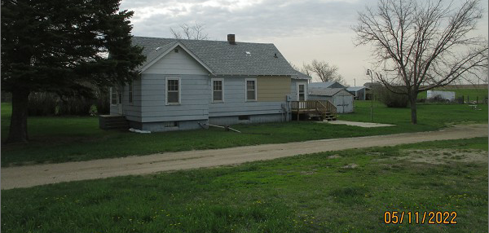
RECORD #6761

LOT SIZE 150’ X 290’ LIVING AREA 900 SQ FT
SINGLE FAMILY – ONE STORY 2 BEDROOMS 2 BATHS
AVERAGE QUALITY – POOR CONDITION BASEMENT 900 SQ FT
BUILT IN 1920 NEWER METAL DET. GAR.
SOLD ON 11/10/2021 FOR $48,000
ASSESSED IN 2021 AT $25,020
SOLD ON 2/6/2017 FOR $10,000 (TAX DEED)
ASSESSED IN 2018 AT $18,790 RECORD #6761

