$260,000.00
JAGER – ARPAN
304 13TH ST WEST
MOBRIDGE THOMPSON’S OUTLOTS E ½ OF LOT 23
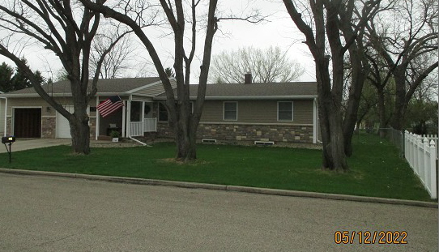
RECORD #6509

LOT SIZE 82.5’ X 264’ TOTAL LIVING 1166 SQ FT
ONE STORY - SINGLE FAMILY 3 BEDROOMS - 1 ¾ BATHS
AVERAGE QUALITY & CONDITION 1166 SQ FT BASEMENT
BUILT IN 1965 600 SQ FT OF BSMT FINISHED
2012; 13’X39’ GARAGE ADDN $20,000 ATTACHED GARAGE 286 SQ FT
2015; ROOF GOOD, 3 EGRESS, CENTRAL AIR NATURAL GAS – CENTRAL AIR
DRIVE THRU ATTACHED GARAGE ROOFED PORCH 84 SQ FT
SOLD ON 12/02/21 FOR $260,000 LARGE CONCRETE SLAB NORTH
ASSESSED IN 2021 AT $169,990 WOOD DECK NORTH
SOLD ON 3/29/19 FOR $211,000
ASSESSED IN 2016 AT $166,240 RECORD #6509

