$1,300,000.00
J & K INVESTMENTS INC – MB57 LLC
301 MAIN ST. MOBRIDGE
MOBRIDGE ORIGINAL PLAT LOTS 11, 12 & 13 BLOCK 3
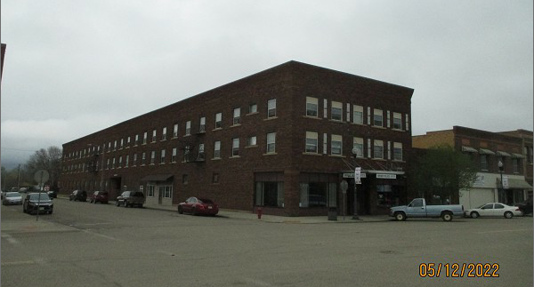
RECORD #6249

LOT SIZE 50’ X 140’ & 50’ X 140’ TOTAL FLOOR AREA 44,000 SQ FT
3 STORY APARTMENT BUILDING BASEMENT 14,000 SQ FT
FAIR CONDITION – AVERAGE QUALITY MASONRY BEARING WALLS
BUILT IN 1920+ -
1993 REMODEL 7 BATHROOMS
2009 REMODEL LOUNGE INTO 2 ONE BEDROOM APTS.
2011 REMODEL 2 APTS. $40,495
SOLD ON 12/03/21 FOR $1,300,000
ASSESSED IN 2021 AT $649,655
SOLD ON 9/01/2006 FOR $800,000
ASSESSED IN 2017 AT $649,655 RECORD #6249

