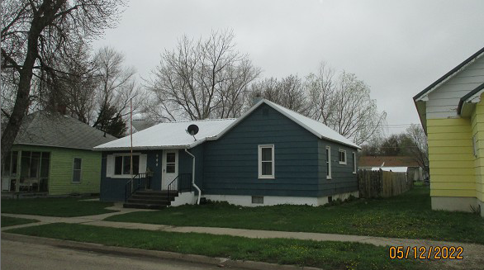
$59,823.00
RICKETTS – GUSTAFSON
319 4TH AVE EAST, MOBRIDGE
MOBRIDGE MILW LAND CO’S 2ND ADDN LOT 2 BLOCK 28
RECORD #5866

LOT SIZE 50’ X 140’ MAIN LIVING 1158 SQ FT
SINGLE FAMILY – 1 STORY 3 BEDROOMS 1 ½ BATHS
AVERAGE QUALITY & CONDITION BASEMENT 1110 SQ FT
BUILT IN 1950 500 SQ FT FIN REC IN BSMT
2014; MASONITE HARDBOARD – FAIR SOLID WALL PORCH 72 SQ FT
ALUM/CASEMENT WINDOWS – FAIR KNEE WALL PORCH 168 SQ FT
POURED FDN, CENTRAL AIR DET. GARAGE 336 SQ FT
SOLD ON 6/14/2021 FOR $59,823 13’ X 8’ UTILITY SHED
ASSESSED IN 2021 AT $47,731
SOLD ON 9/03/08 FOR $31,500
ASSESSED IN 2016 AT $36,475 RECORD #5866

