$440,000.00
STEWART – JAGER
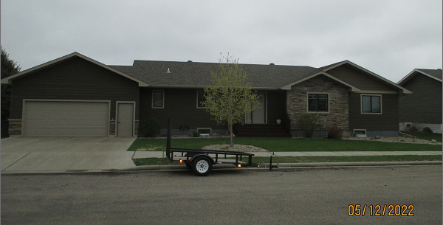
1403 SUNSET AVE. MOBRIDGE
MOBRIDGE JAY-KRAFT 2ND ADDN LOT 12A BLOCK 3
RECORD #5542

LOT SIZE 114.6’ X 126.33’ MAIN LIVING 1883 SQ FT
SINGLE FAMILY – 1 STORY 3 BEDROOMS - 2 ½ BATHS
AVERAGE QUALITY & CONDITION FINISHED BASEMENT 2008 SQ FT
BUILT IN 2014 ATTACHED GARAGE 576 SQ FT
SLIDING GLASS DOOR WEST
2 EGRESSES ON WEST, NORTH & EAST
NATURAL GAS – CENTRAL AIR
SOLD ON 11/29/21 FOR $440,000
ASSESSED IN 2021 AT $266,220
ASSESSED IN 2018 AT $253,380 RECORD #5542

