$35,000.00
ROWE – SHILLINGSTAD
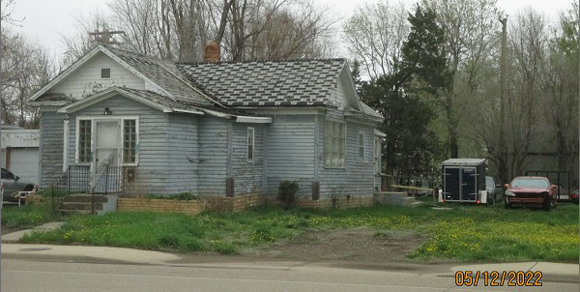
516 EAST GRAND CROSSING, MOBRIDGE
MOBRIDGE FAIRVIEW ADDN LOTS 4 THRU 7 BLOCK 28
RECORD #5167

LOT SIZE 100’ X 140’ MAIN LIVING 976 SQ FT
SINGLE FAMILY – 1 STORY 2 BEDROOMS 1 ½ BATHS
POOR CONDITION & QUALITY SOLID WALL PORCH 147 SQ FT
BUILT IN 1930 OPEN SLAB 195 SQ FT
2014; ROOF POOR, LAP SIDING POOR
ALUMINUM WINDOWS POOR
WINDOW AIR
SOLD ON 11/19/21 FOR $35,000
ASSESSED IN 2021 AT $27,110 RECORD #5167
SOLD ON 10/14/11 FOR $8,375
ASSESSED IN 2016 AT $15,560

