$147,500.00
MARTIAN – FICK
1303 PARK LANE AVE. MOBRIDGE
MOBRIDGE BEL AIRE 1ST ADDN LOT 4 BLOCK 5
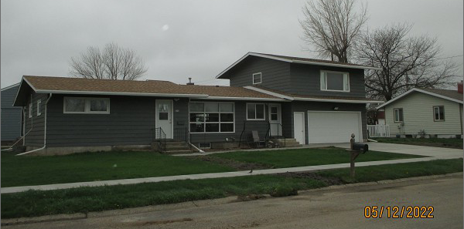
RECORD #4720

LOT SIZE 65’ X 130’ GROUND FLOOR 1680 SQ FT
SINGLE FAMILY – 1 STORY BSMT 576 SQ FT
AVERAGE QUALITY & CONDITION LIVING QUARTERS ABOVE GARAGE
BUILT IN 1959 3 BEDROOMS INCLUDING GARAGE
2014; SHINGLES FAIR, MASONITE FAIR 2 BATHS INCLUDING ABOVE GARAGE
NATURAL GAS – CENTRAL AIR ATTACHED GARAGE 576 SQ FT
POURED FDN SOME CRACKING
EGRESS WINDOW
SOLD ON 10/01/2021 FOR $147,500
ASSESSED IN 2021 AT $104,770
SOLD ON 5/28/15 FOR $127,000
ASSESSED IN 2016 AT $101,830 RECORD #4720

