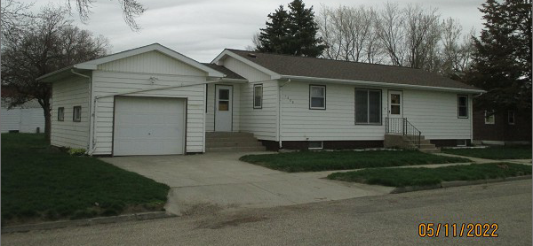
$60,000.00
GEREAU – WUDEL
1608 2ND AVE. SELBY
SELBY ORIGINAL E ½ LOTS 2 & 3 BLOCK 19
RECORD #4531

LOT SIZE 101.6’ X 70 MAIN LIVING 1092 SQ FT
SINGLE FAMILY – ONE STORY 3 BEDROOMS – 2 BATHS
AVERAGE QUALITY & CONDITION FINISHED BSMT 600 SQ FT
BUILT IN 1964 SWP 140 SQ FT
2015; MASONITE – GOOD, ROOF GOOD OPEN SLAB 500 SQ FT
NATURAL GAS – CENTRAL AIR ATTACHED GAR. 336 SQ FT
WINDOWS FAIR, BLOCK FOUNDATION 8’ X 10’ UTILITY SHED
SOLD ON 9/30/2021 FOR $60,000
ASSESSED IN 2021 AT $59,830
ASSESSED IN 2016 AT $57,370 RECORD #4531

