$6,800.00
GOETZ – RODRIGUEZ
2508 3RD AVE. SELBY
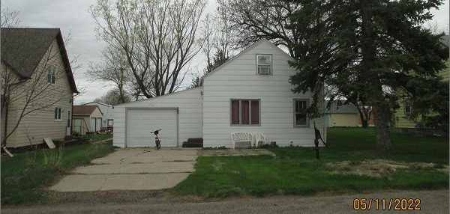
SELBY ORIGINAL LOT 2 BLOCK 13
RECORD #4490

LOT SIZE 50’ X 140’ GROUND FLOOR 540 SQ FT
SINGLE FAMILY- 1 STORY/ATTIC TOTAL LIVING 684 SQ FT
FAIR CONDITION – QUALITY 2 BEDROOMS 1 BATH
BUILT IN 1910 WOOD DECK 88 SQ FT
2015; MASONITE TO GROUND ATTACHED GARAGE 389 SQ FT
NATURAL GAS, WINDOW AIR
ALUMINUM/WOOD WINDOWS FAIR
SOLD ON 8/30/21 FOR $6,800
ASSESSED IN 2021 AT $11,900
SOLD ON 10/7/16 FOR $5,863
ASSESSED IN 2017 AT $8,270 RECORD #4490

