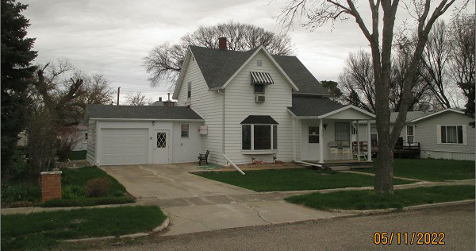
$75,000.00
STOICK – STEDER
3507 3RD AVE EAST, SELBY
SELBY ORIGINAL LOT 10 & S ½ LOT 11 BLOCK 9
RECORD #4463

LOT SIZE 75’ X 140’ MAIN FLOOR 1004 SQ FT
SINGLE FAMILY – 1 ½ STORY TOTAL LIVING 2279 SQ FT
AVERAGE QUALITY & CONDITION 4 BEDROOMS 2 BATHS
BUILT IN 1910 + - ATT. GAR. 252 SQ FT
2015; ROOF GOOD, POURED FDN DET. GAR. 288 SQ FT
MASONITE & VERTICAL HARDBOARD ROOFED PORCH 72 SQ FT
NATURAL GAS, BAY WINDOWS WOOD DECK 245 SQ FT
SOLD ON 6/11/2021 FOR $75,000
ASSESSED IN 2021 AT $87,760
ASSESSED IN 2016 AT $85,170 RECORD #4463

