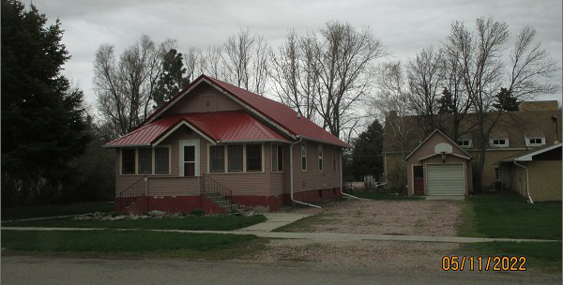
$43,000.00
SHILLINGSTAD – LASSER
207 W. THEODORE, SELBY
SELBY ORIGINAL LOTS 4 & 5 BLOCK 6
RECORD #4435

LOT SIZE 100’ X 130’ MAIN FLOOR 1000 SQ FT
SINGLE FAMILY TOTAL LIVING 1250 SQ FT
ONE STORY/ATTIC 2 BEDROOMS 2 BATHS
AVERAGE QUALITY & CONDITION KNEE WALL PORCH 161 SQ FT
BUILT IN 1920 SOLID WALL PORCH 81 SQ FT
2015; WOOD LAP POOR, METAL ROOF BASEMENT 1000 SQ FT
WINDOW AIR, NATURAL GAS DETACHED GARAGE304 SQ FT
FOUNDATION CONCERNS, 3 SEASON PORCH
SOLD ON 7/14/21 FOR $43,000
ASSESSED IN 2021 AT $33,900
SOLD ON 12/15/15 FOR $30,000
ASSESSED IN 2016 AT $26,180 RECORD #4435

