$37,500.00
STOICK – C-SAW RENTALLS LLC
4311 4TH ST. SELBY
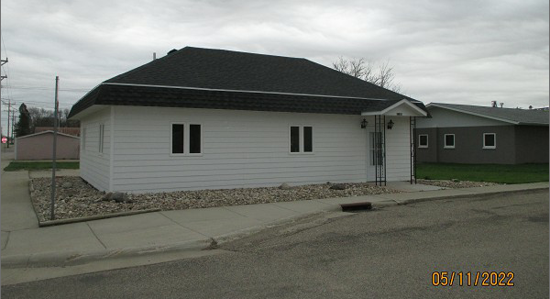
SELBY ORIGINAL N 46’ LOT 17 & ALL LOT 18 BLOCK 4
RECORD #4432

LOT SIZE 96’ X 140’ MAIN LIVING 842 SQ FT
SINGLE FAMILY – 1 STORY 2 BEDROOMS 1 BATH
AVERAGE QUALITY & CONDITION
BUILT 1920 + -
2015; ROOF GOOD, CENTRAL AIR
CEMENT BOARD FAIR, METAL/METAL GOOD
2021; TOTAL INTERIOR RE-MODEL
SOLD ON 10/19/21 FOR $37,500
ASSESSED IN 2021 AT $29,940
ASSESSED IN 2017 AT $26,620 RECORD #4432

